**DBMS EXERCISE : 2**

**NAME : KAUSHAL BAGHEL**  **ROLL NO 21MAI0003**

Aim: To know how the constraints are used to make table is consistent.

**ADDING CONSTRAINT IN EMPLOYEE TABLE.**

ALTER TABLE EMPLOYEE MODIFY(FIRST_NAME VARCHAR(15) CONSTRAINT FNAME NOT NULL);

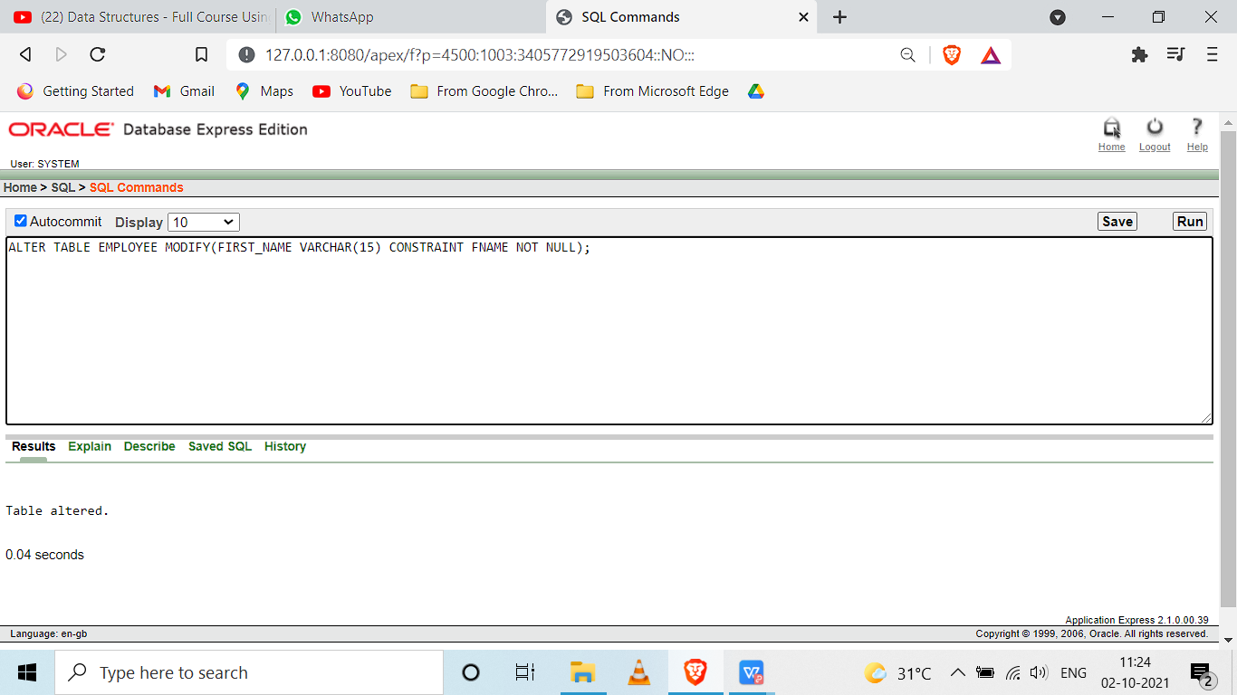

ALTER TABLE EMPLOYEE MODIFY(LAST_NAME VARCHAR(15) CONSTRAINT LNAME NOT NULL);

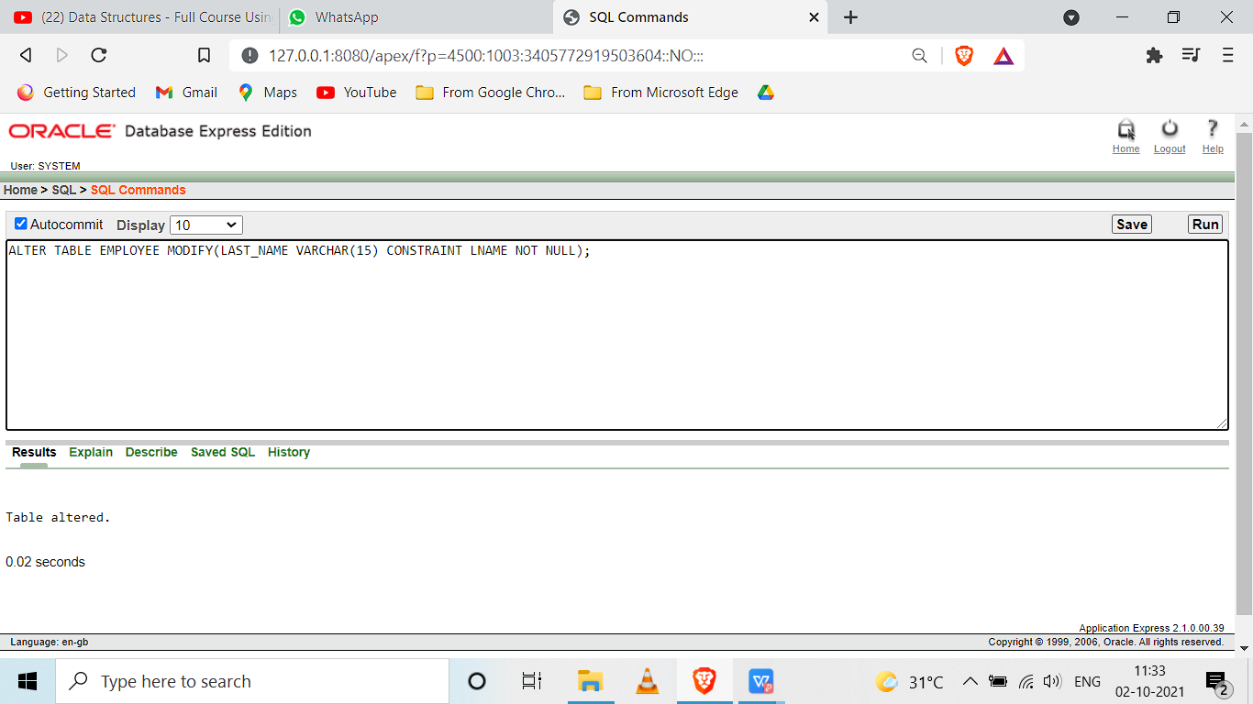

ALTER TABLE EMPLOYEE ADD CONSTRAINT CON_SSN PRIMARY KEY(SSN_NUMBER);

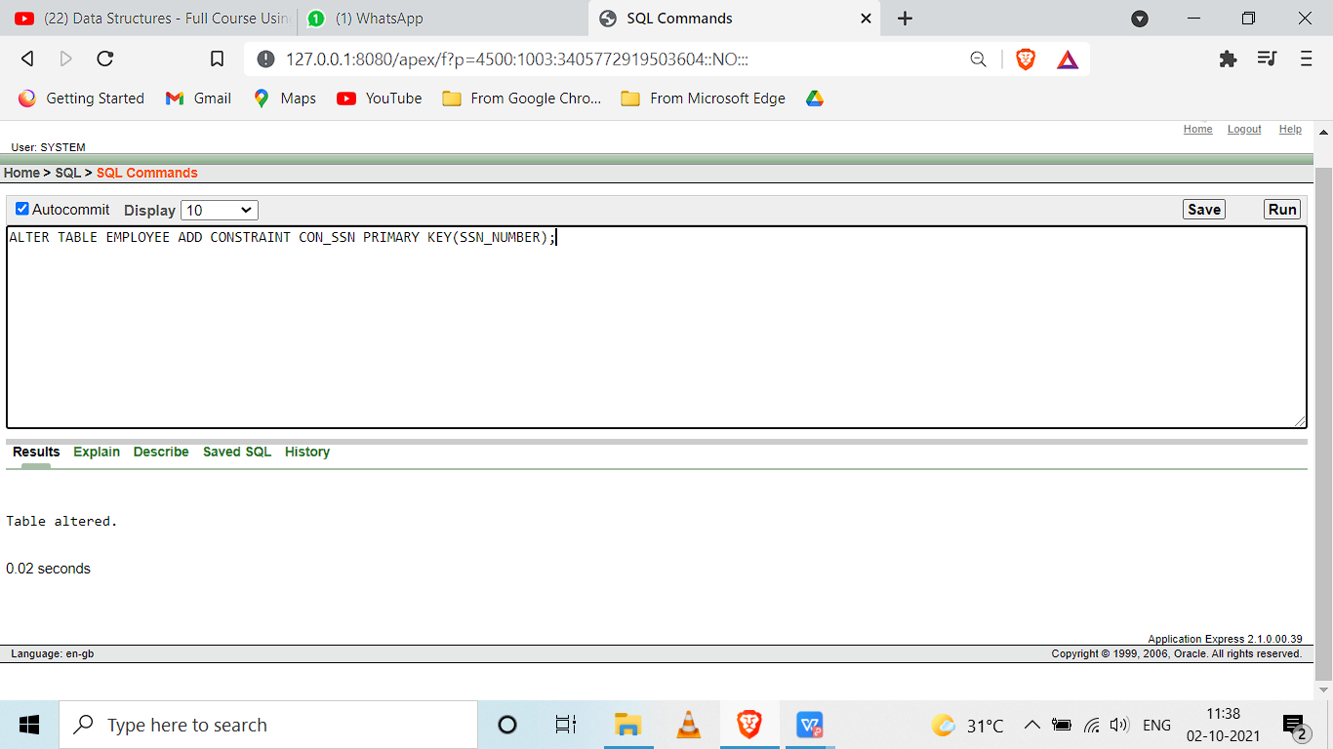

ALTER TABLE EMPLOYEE ADD CONSTRAINT CON_SEX CHECK(SEX IN ('M','F','m','f'));

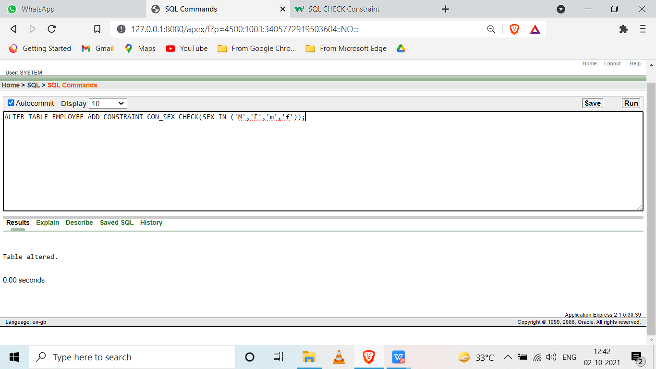

ALTER TABLE EMPLOYEE MODIFY SALARY DEFAULT 800;

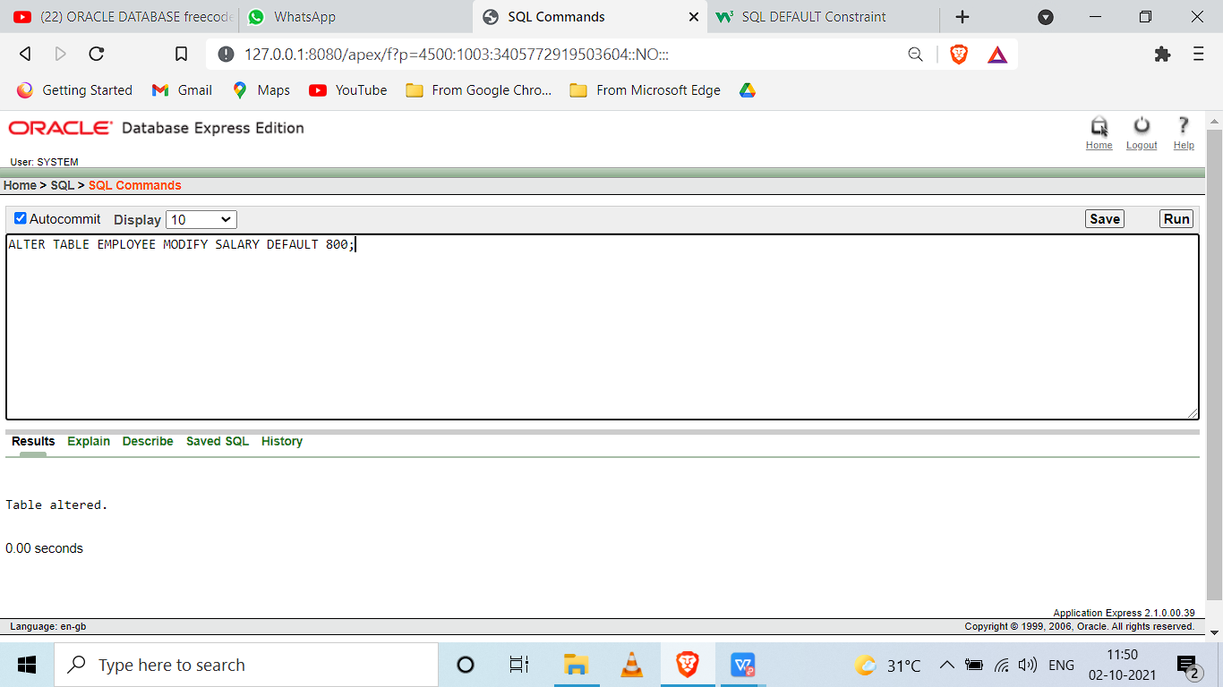

ALTER TABLE EMPLOYEE

ADD CONSTRAINT CON_SUPERVISOR_SSN

FOREIGN KEY (SUPERVISOR_SSN)

REFERENCES EMPLOYEE(SSN_NUMBER)

ON DELETE SET NULL;

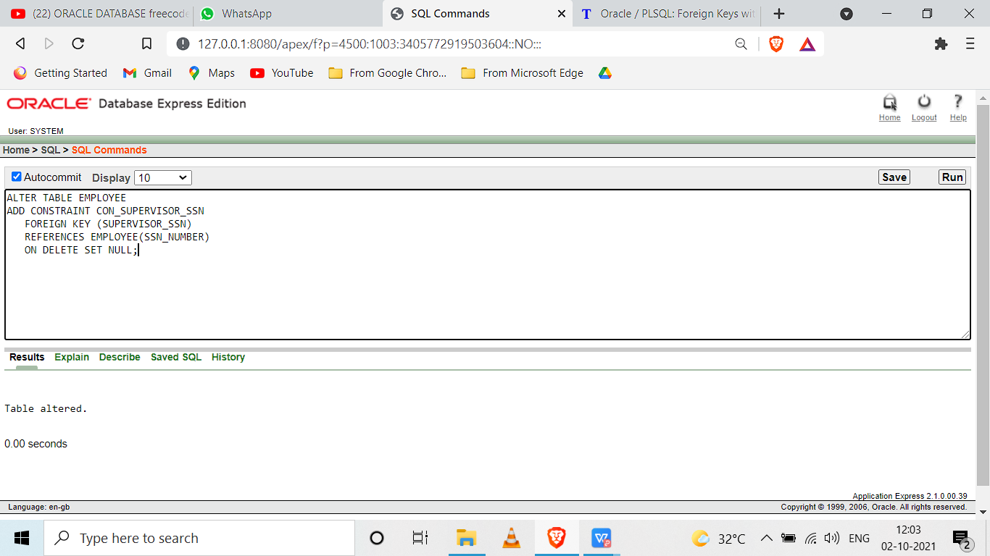

ALTER TABLE EMPLOYEE

ADD CONSTRAINT CON_DNO

FOREIGN KEY (DEPT_NUMBER)

REFERENCES DEPARTMENT(DEPT_NO)

ON DELETE CASCADE;

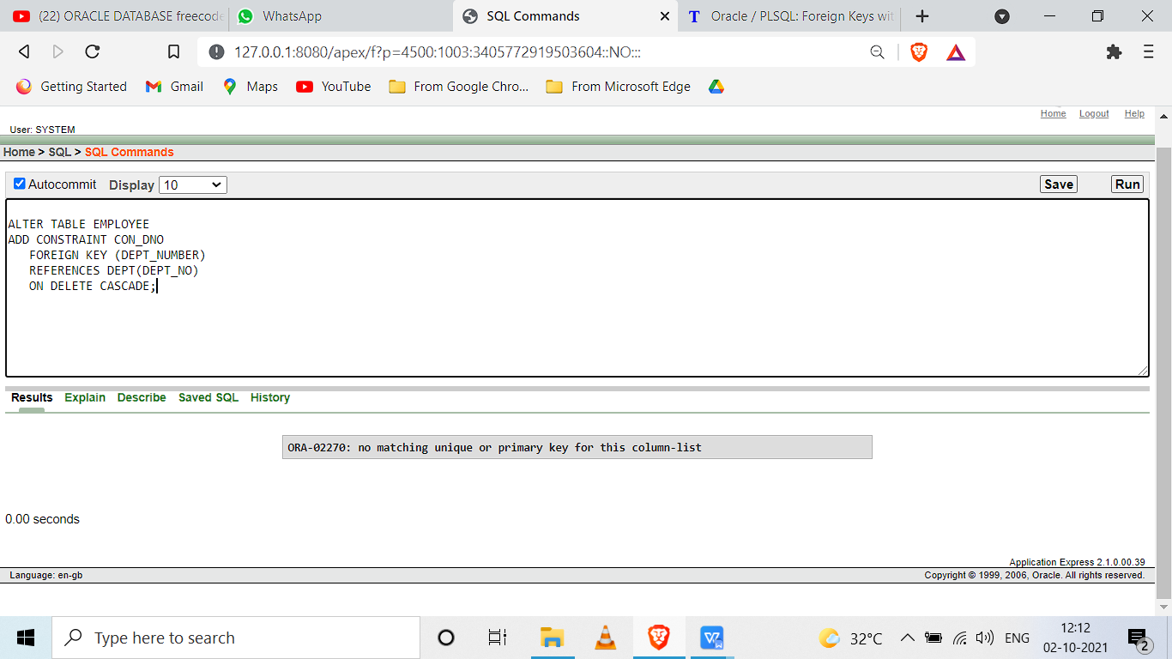

**ADDING CONSTRAINT IN DEPARTMENT TABLE.**

ALTER TABLE DEPT MODIFY(DEPT_NAME VARCHAR2(15) CONSTRAINT DNAME NOT NULL);

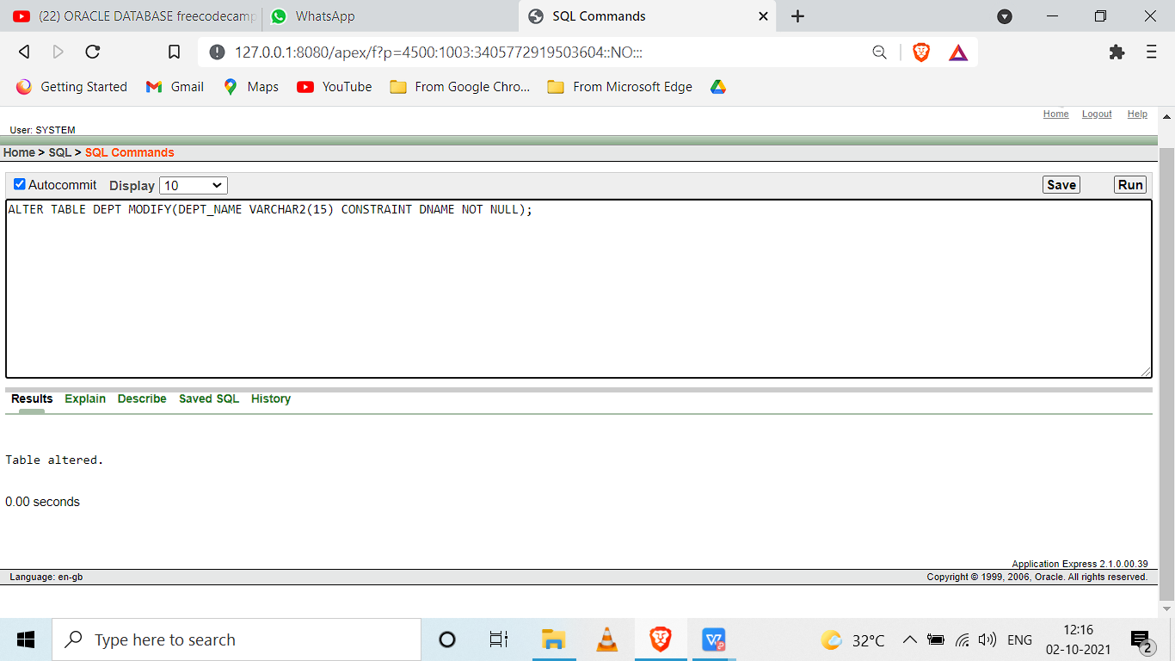

ALTER TABLE DEPT ADD CONSTRAINT CON_DEPT_NO PRIMARY KEY(DEPT_NO);

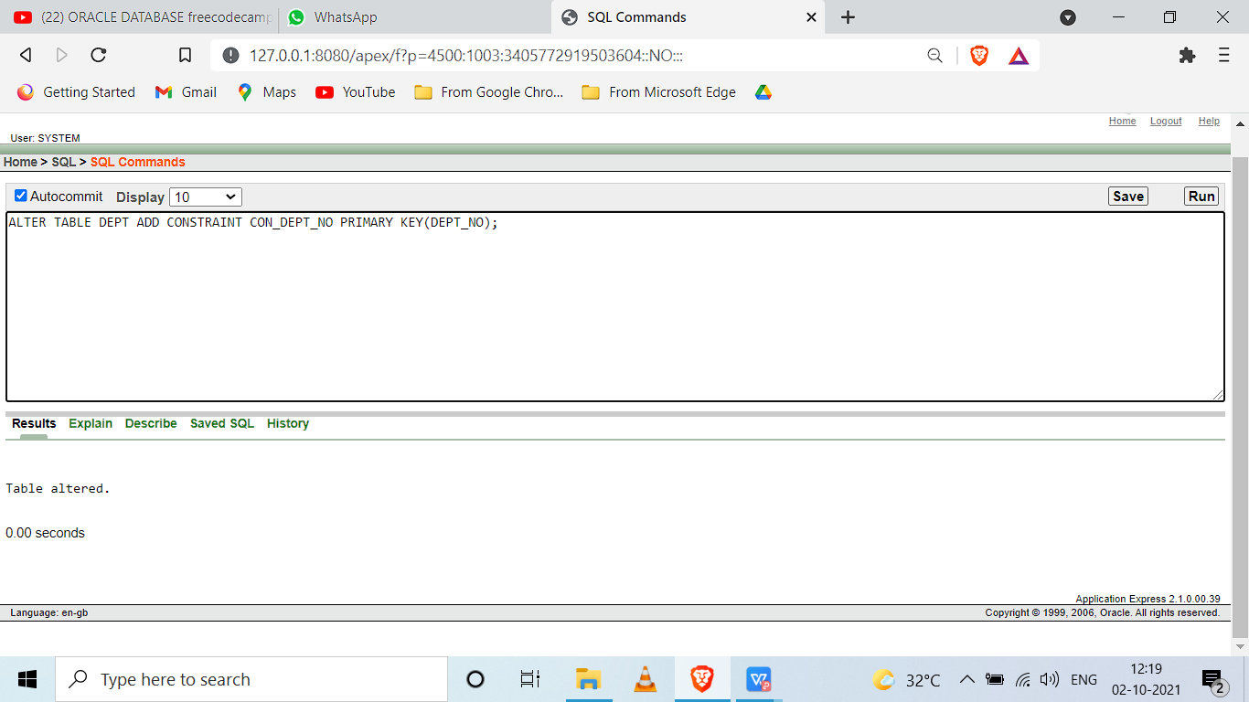

ALTER TABLE DEPT

ADD CONSTRAINT CON_FK_MANAGER_SSN

FOREIGN KEY (MANAGERSSN)

REFERENCES EMPLOYEE(SSN_NUMBER)

ON DELETE SET NULL;

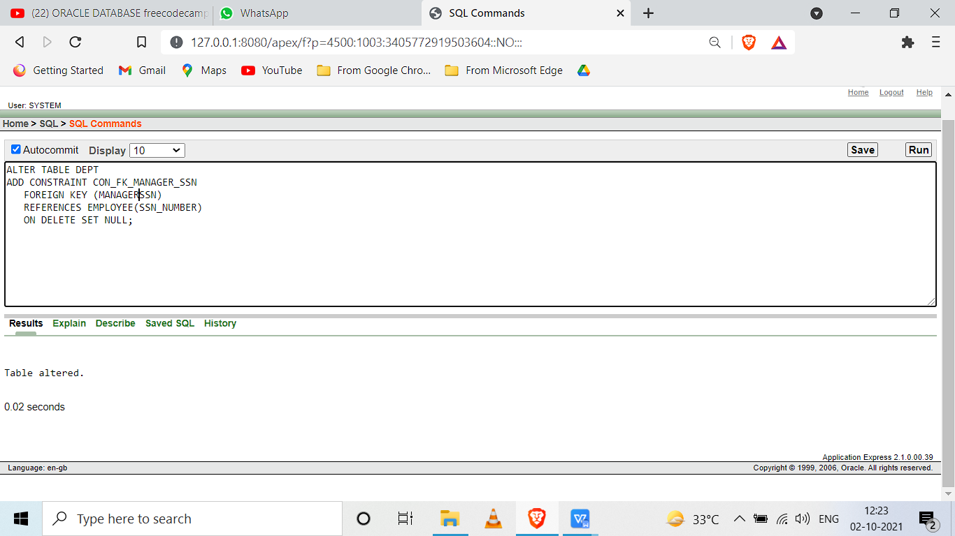

**ADDING CONSTRAINT IN PROJECT TABLE.**

ALTER TABLE PROJECT MODIFY(PROJECTNAME VARCHAR2(15) CONSTRAINT PNAME NOT NULL);

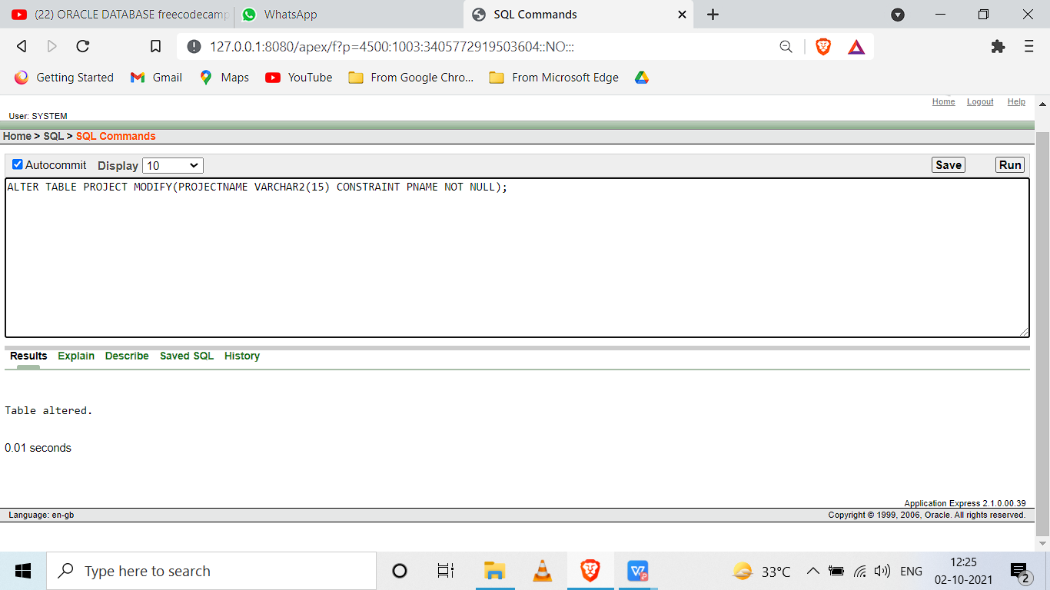

ALTER TABLE PROJECT ADD CONSTRAINT CON_PK PRIMARY KEY(PROJECTNUMBER);

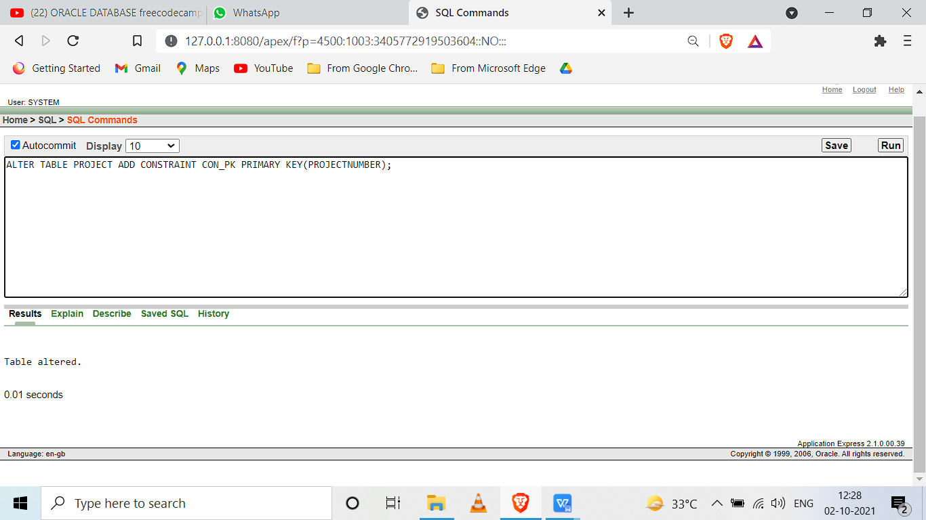

ALTER TABLE PROJECT

ADD CONSTRAINT CON_PROJECT_FK

FOREIGN KEY (DEPT_NO)

REFERENCES DEPT(DEPT_NO)

ON DELETE SET NULL;

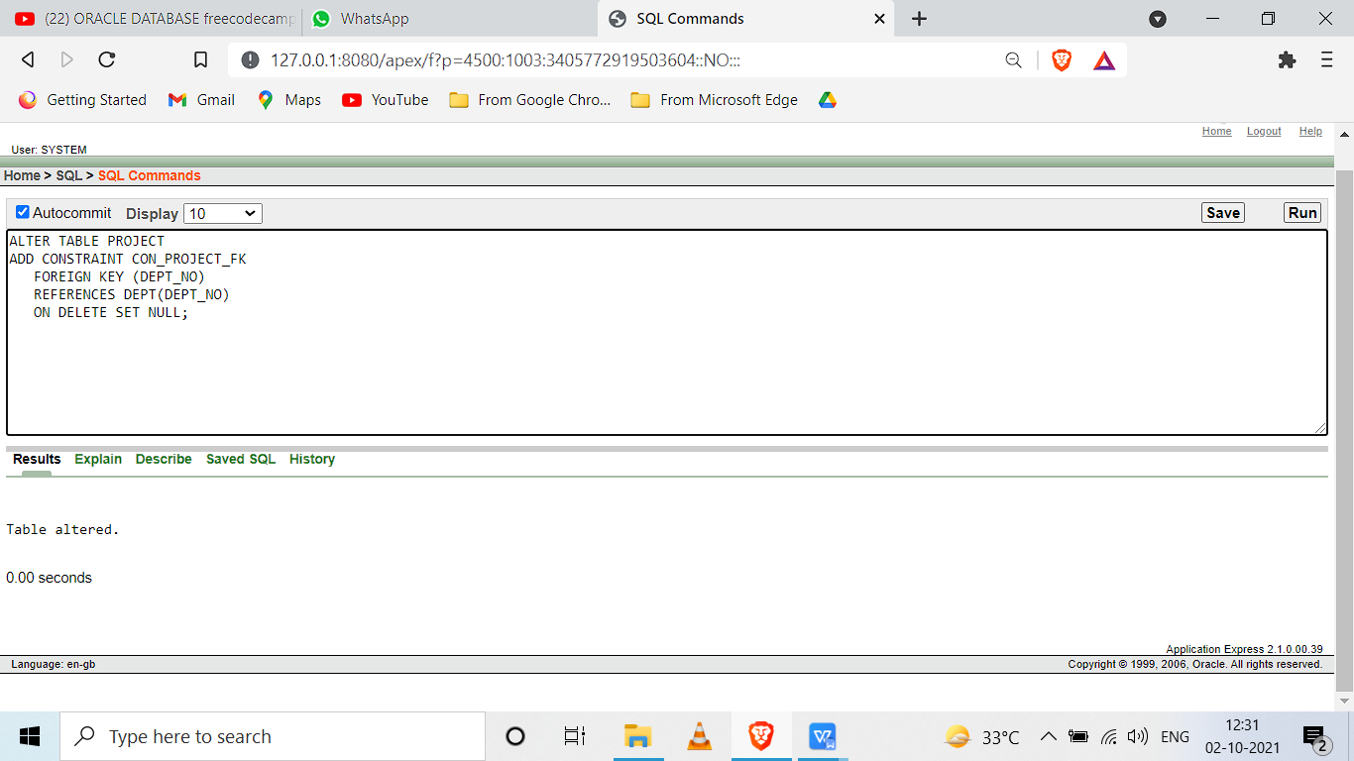

**CREATING NEW TABLES DEPARTMENT_LOCATIONS,WORKS_ON, AND DEPENDENT WITH CONSTRAINTS.**

CREATE TABLE DEPT_LOCATIONS( DEPT_NO NUMBER(5),DEPT_LOCATION VARCHAR (15) ,CONSTRAINT CON_DELETE FOREIGN KEY(DEPT_NO) REFERENCES DEPT(DEPT_NO) ON DELETE CASCADE);

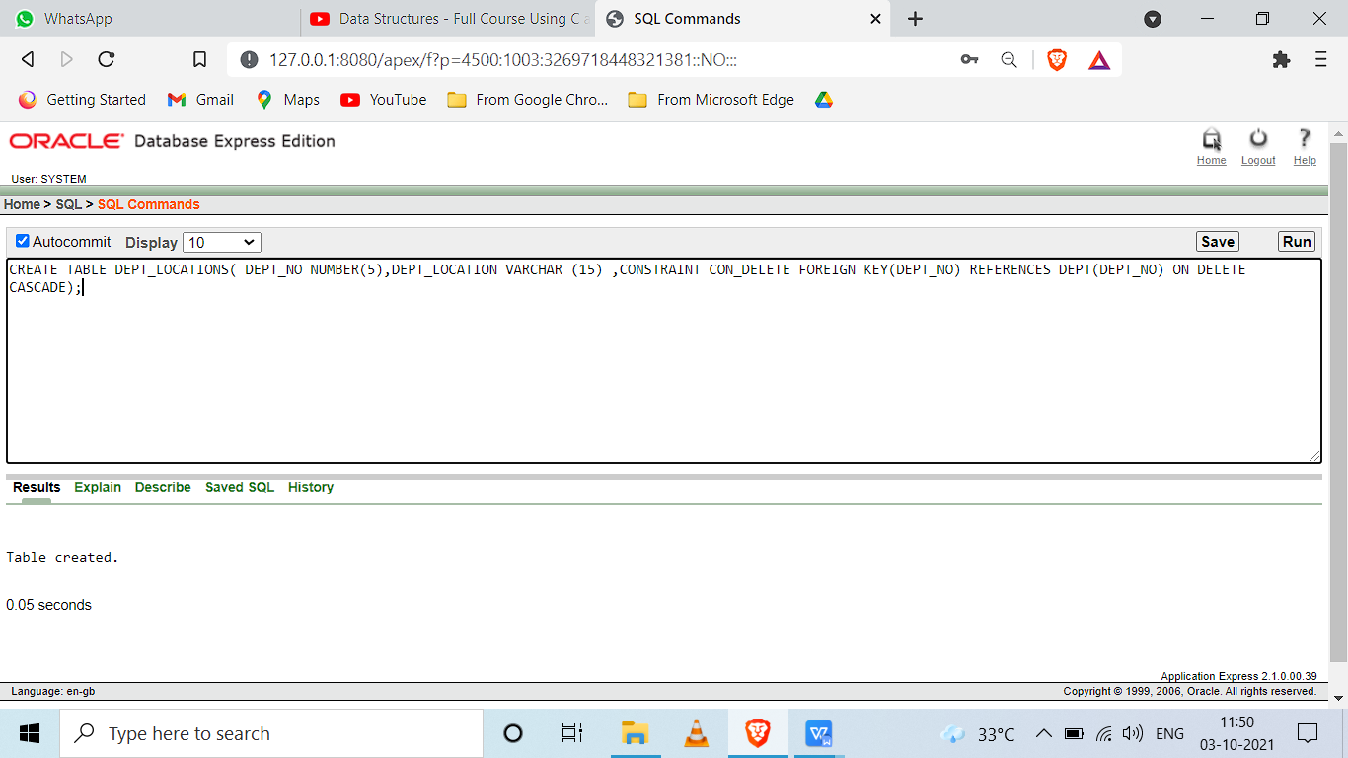

CREATE TABLE WORKS_ON(EMPLOYEE_SSN CHAR(9),PROJECT_NUMBER INT ,HOURS DECIMAL(3,1) NOT NULL,CONSTRAINT CON_EMPLOYEE_SSN FOREIGN KEY(EMPLOYEE_SSN) REFERENCES EMPLOYEE(SSN_NUMBER) ON DELETE CASCADE,CONSTRAINT CON_PROJECT_NUMBER FOREIGN KEY(PROJECT_NUMBER) REFERENCES PROJECT(PROJECTNUMBER) ON DELETE CASCADE);

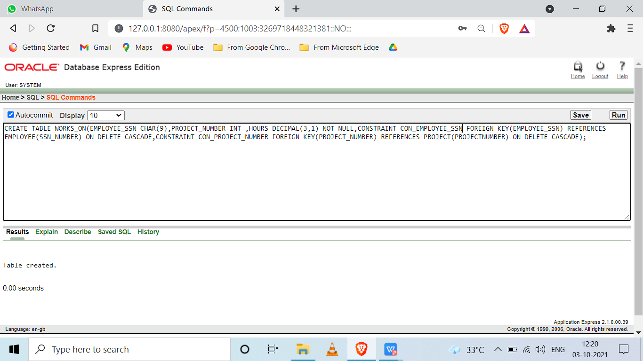

ALTER TABLE WORKS_ON

ADD CONSTRAINT CON_PK1 PRIMARY KEY (EMPLOYEE_SSN,PROJECT_NUMBER);

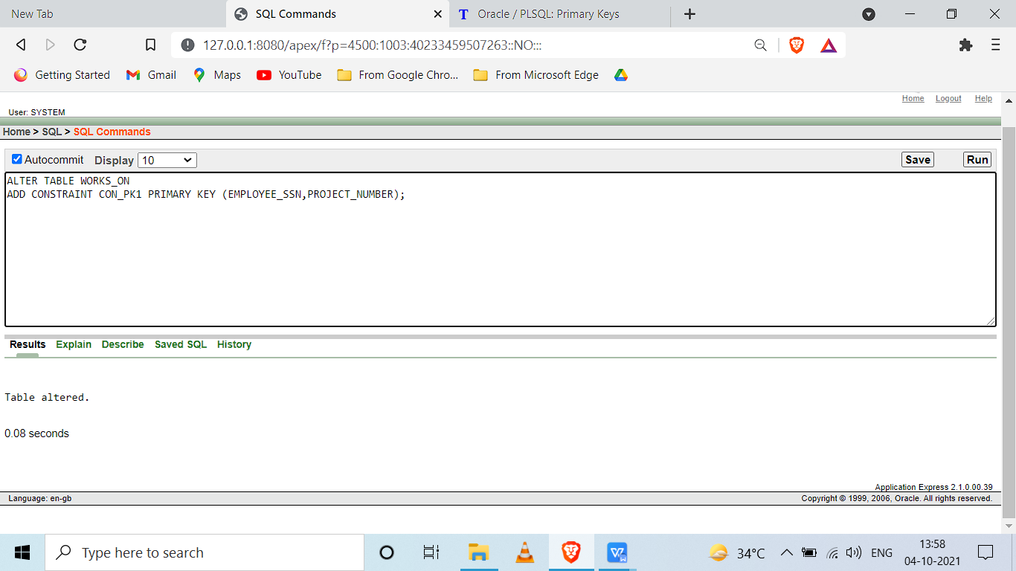

CREATE TABLE DEPENDENT(EMPLOYEE_SSN CHAR(9),DEPENDENT_NAME VARCHAR(15) ,SEX CHAR(1),BIRTHDAY DATE ,RELATIONSHIP VARCHAR(8),CONSTRAINT CON_FK_EMPLOYEE_SSN FOREIGN KEY(EMPLOYEE_SSN) REFERENCES EMPLOYEE(SSN_NUMBER) ON DELETE CASCADE,CONSTRAINT CON_SEX_CHECK CHECK(SEX IN('M','F','m','f')),CONSTRAINT CON_PKEY PRIMARY KEY(EMPLOYEE_SSN,DEPENDENT_NAME));

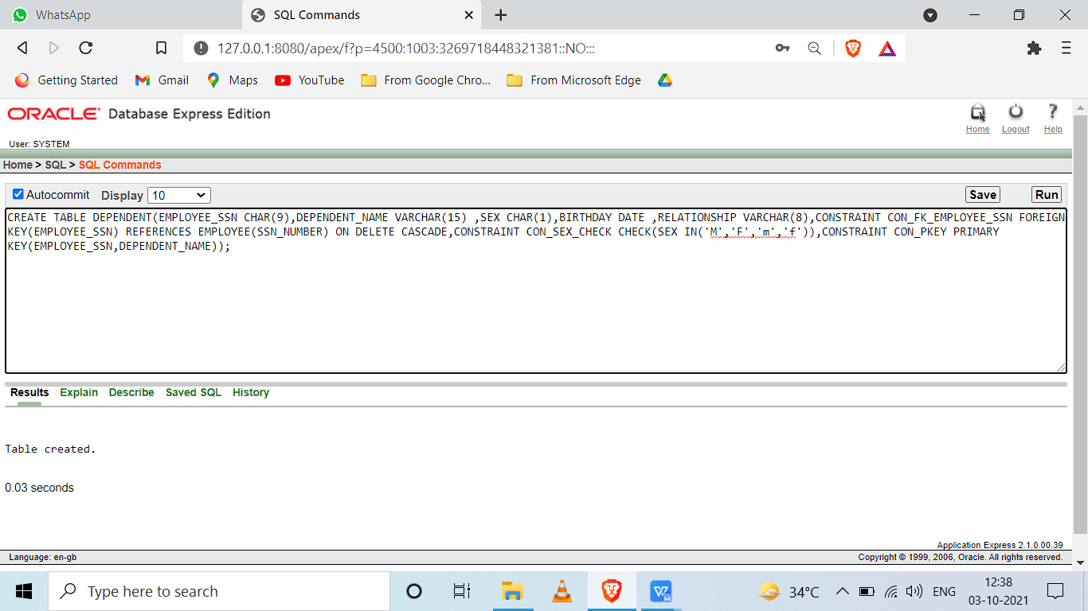

INSERTING DATA INTO DEPARTMENT LOCATIONS TABLE

INSERT INTO DEPT_LOCATIONS VALUES(1,'HOUSTON');

INSERT INTO DEPT_LOCATIONS VALUES(1,'CHICAGO');

INSERT INTO DEPT_LOCATIONS VALUES(2,'NEW YORK');

INSERT INTO DEPT_LOCATIONS VALUES(2,'SAN FRANCISCO');

INSERT INTO DEPT_LOCATIONS VALUES(3,'SALT LAKE CITY');

INSERT INTO DEPT_LOCATIONS VALUES(4,'STAFFORD');

INSERT INTO DEPT_LOCATIONS VALUES(4,'BELLAIRE');

INSERT INTO DEPT_LOCATIONS VALUES(5,'SUGARLAND');

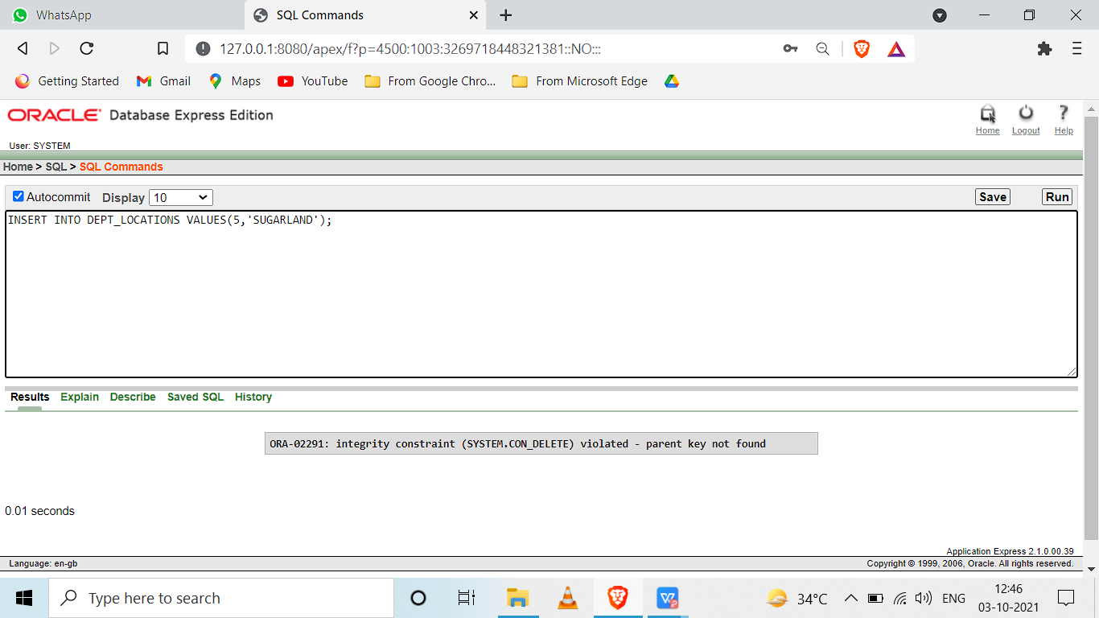

INSERT INTO DEPT_LOCATIONS VALUES(5,'HOUSTON');

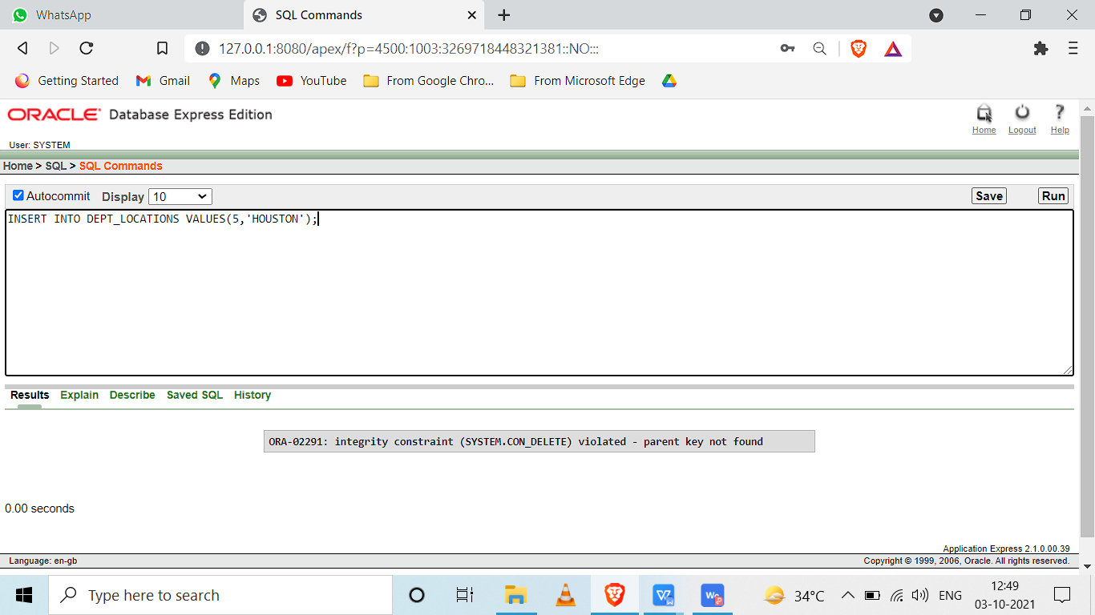

TO RESOLVE THIS PROBLEM WE NEED TO ADD DUMMY DATA WITH DEPT NO=5 IN DEPT TABLE.

INSERT INTO DEPT VALUES('UNSPECIFIED', 5, 123, '12-JUN-2015');

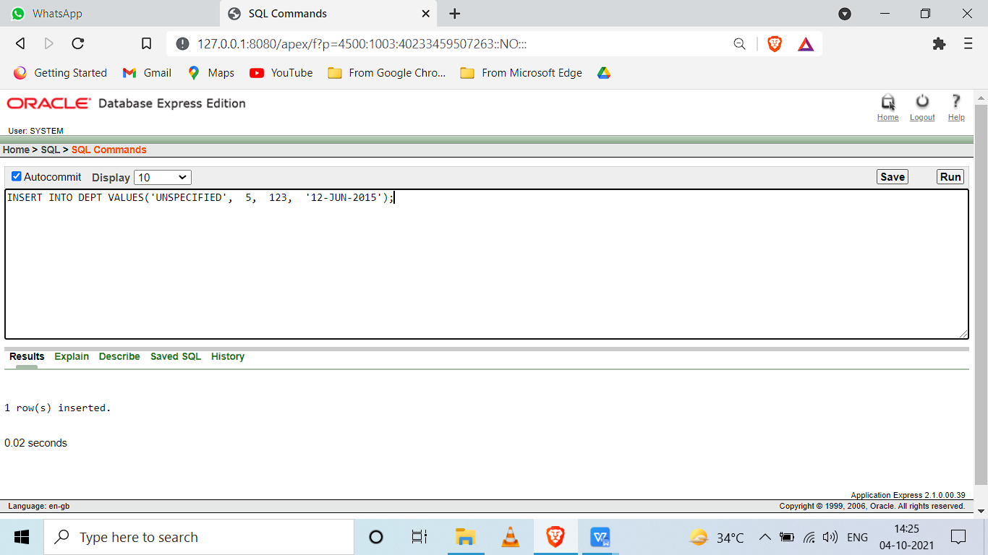

INSERT INTO DEPT_LOCATIONS VALUES(5,'SUGARLAND');

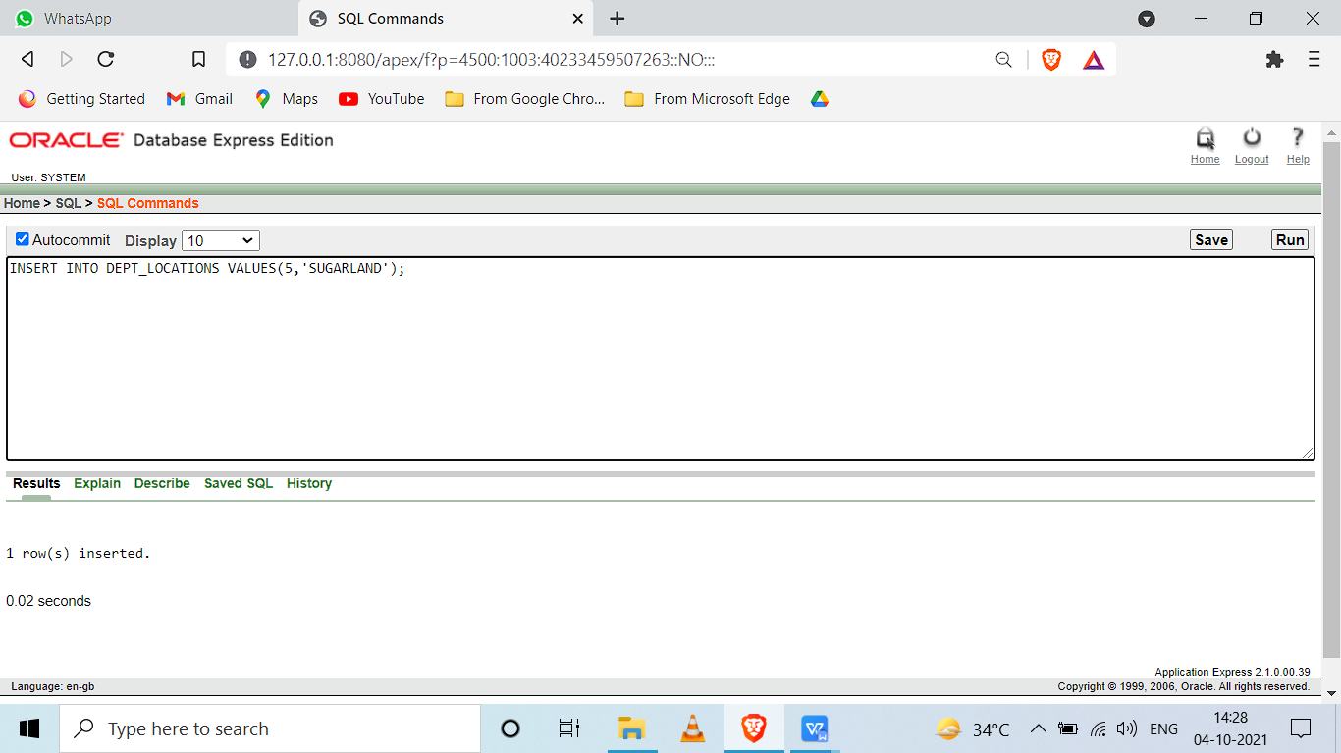

INSERT INTO DEPT_LOCATIONS VALUES(5,'HOUSTON');

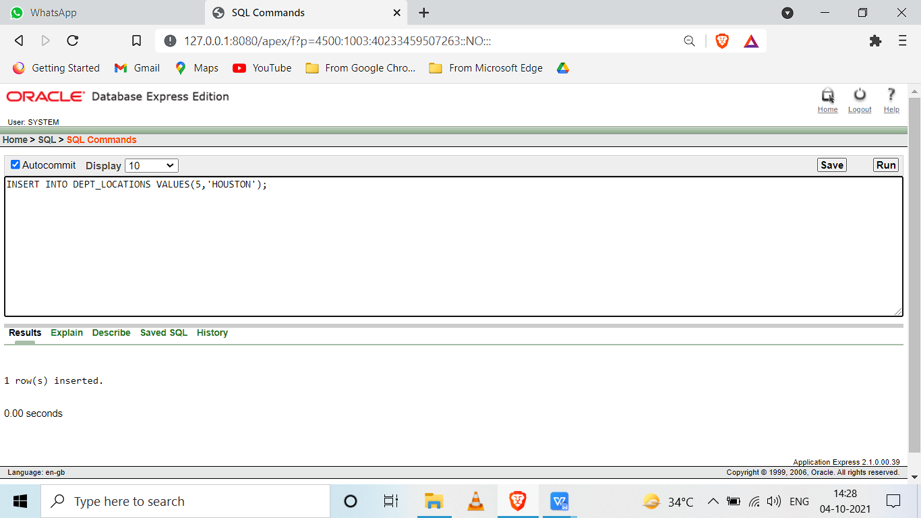

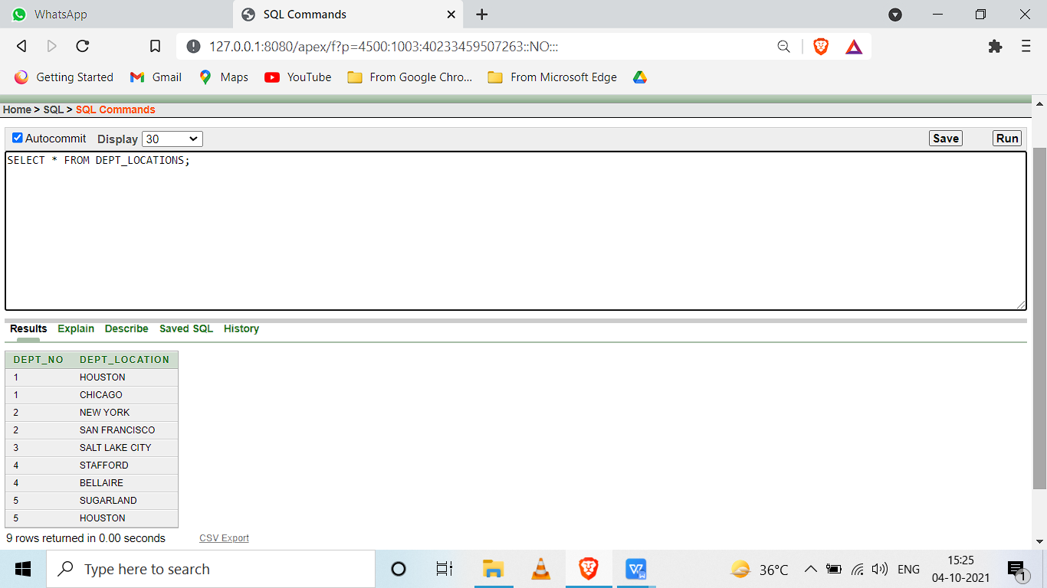

INSERTING DATA INTO WORKS_ON TABLE

INSERT INTO WORKS_ON VALUES('666884444',3388,40.0);

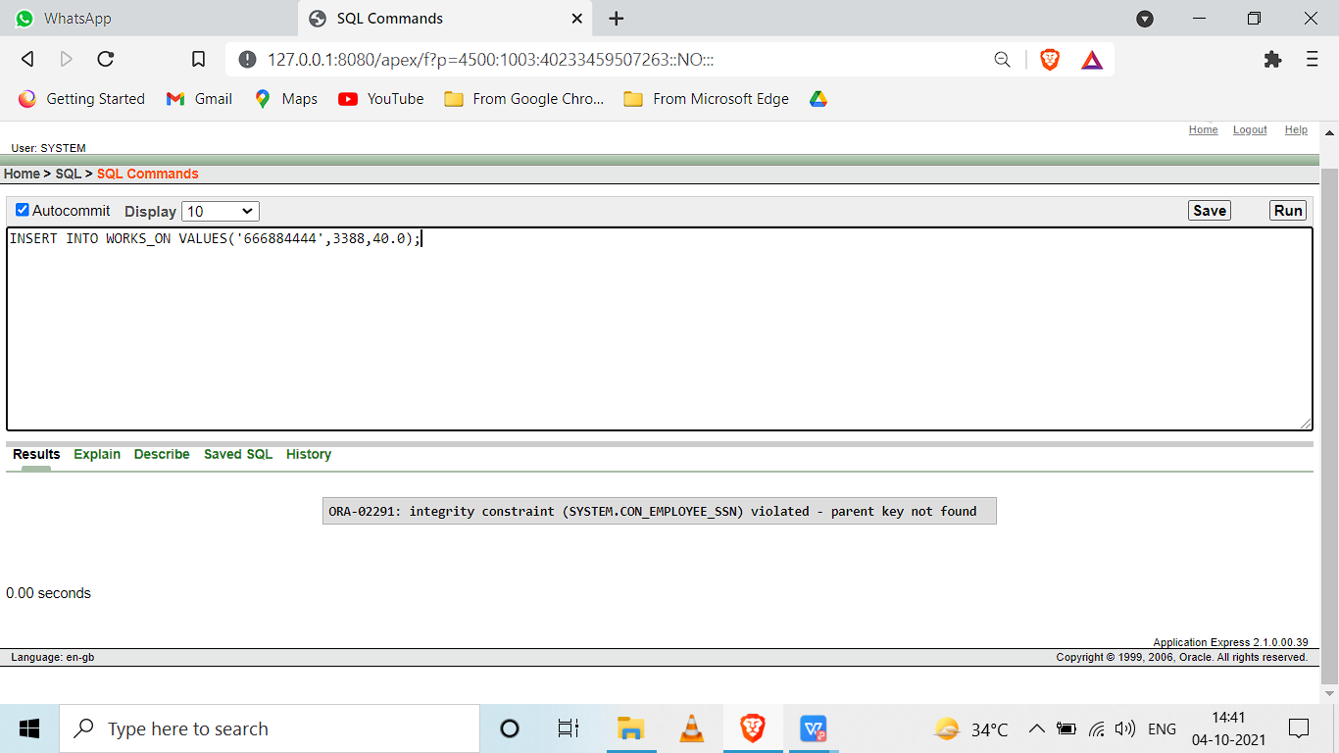

ADDING DUMMY DATA TO RESOLVE INTEGRITY CONSTRAINTS.

INSERT INTO EMPLOYEE VALUES('ALBERT', NULL, 'EINSTEIN',123456789,'09-JUN-1969', 'CHENNAI', 'M', 80000, NULL , 4);

INSERT INTO EMPLOYEE VALUES('NIKOLA', NULL, 'TESLA',666884444,'09-JUN-1970', 'CHENNAI', 'M', 90000, NULL , 4);

INSERT INTO EMPLOYEE VALUES('ELON', NULL, 'MUSK',453453453,'09-JUN-1970', 'CHENNAI', 'M', 90000, NULL , 4);

INSERT INTO EMPLOYEE VALUES('JEFF', NULL, 'BEZOS',333445555,'09-JUN-1971', 'CHENNAI', 'M', 10000, NULL , 4);

INSERT INTO EMPLOYEE VALUES('STEVE', NULL, 'JOBS',999887777,'09-JUN-1972', 'CHENNAI', 'M', 10000, NULL , 4);

INSERT INTO EMPLOYEE VALUES('BRUCE', NULL, 'WAYNE',543216789,'09-JUN-1973', 'CHENNAI', 'M', 90000, NULL , 4);

INSERT INTO EMPLOYEE VALUES('TONY', NULL, 'STARK',554433221,'09-JUN-1974', 'CHENNAI', 'M', 90000, NULL , 4);

ADDING DUMMY DATA TO PROJECT TABLE.

INSERT INTO PROJECT VALUES('ProjectB', 77 , 'HYDERABAD', 1 );

INSERT INTO PROJECT VALUES('ProjectB', 12 , 'HYDERABAD', 1 );

INSERT INTO PROJECT VALUES('ProjectB', 22 , 'HYDERABAD', 1 );

INSERT INTO PROJECT VALUES('ProjectB', 43 , 'HYDERABAD', 1 );

INSERT INTO PROJECT VALUES('ProjectB', 1 , 'HYDERABAD', 1 );

INSERT INTO PROJECT VALUES('ProjectB', 12 , 'HYDERABAD', 1 );

INSERTING DATA INTO WORKS_ON TABLE.

INSERT INTO WORKS_ON VALUES('123456789', 3388 , 32.5 );

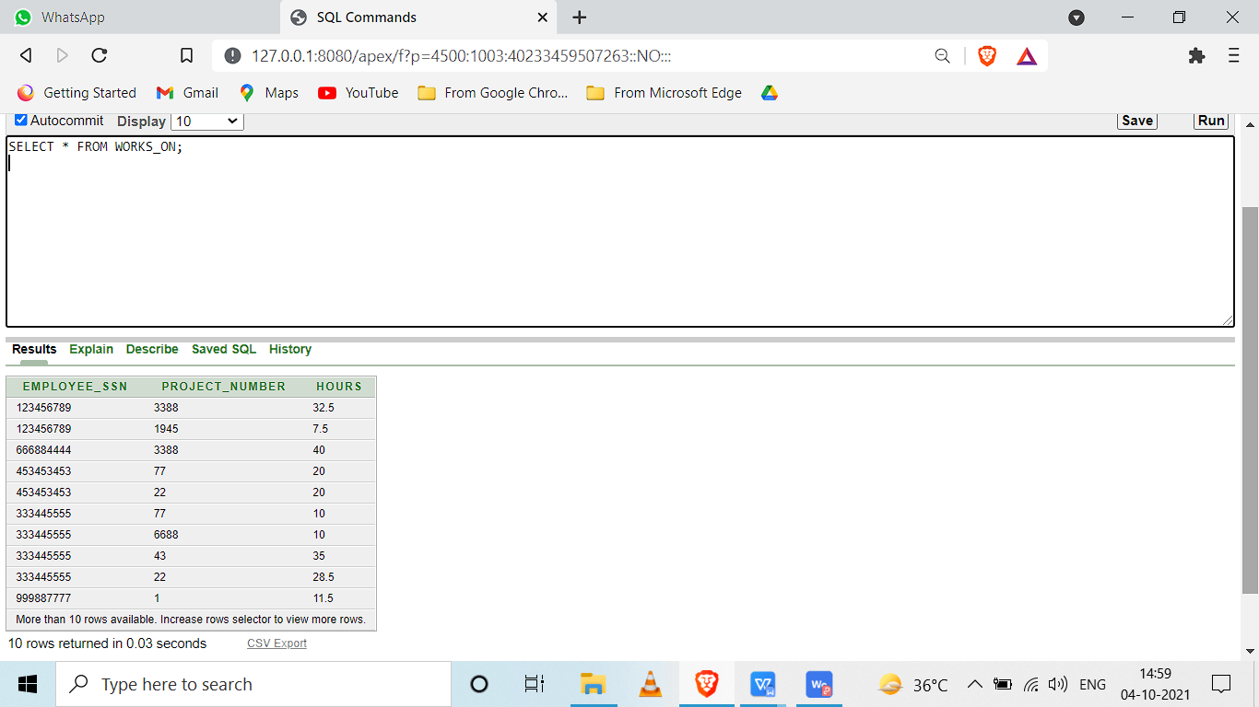

INSERTING DATA INTO DEPENDENT TABLE.

INSERT INTO DEPENDENT VALUES('333445555','ALICE','F','05-APR-1976','DAUGHTER');

INSERT INTO DEPENDENT VALUES('987654321','ABNER','M','29-FEB-1932','SPOUSE');

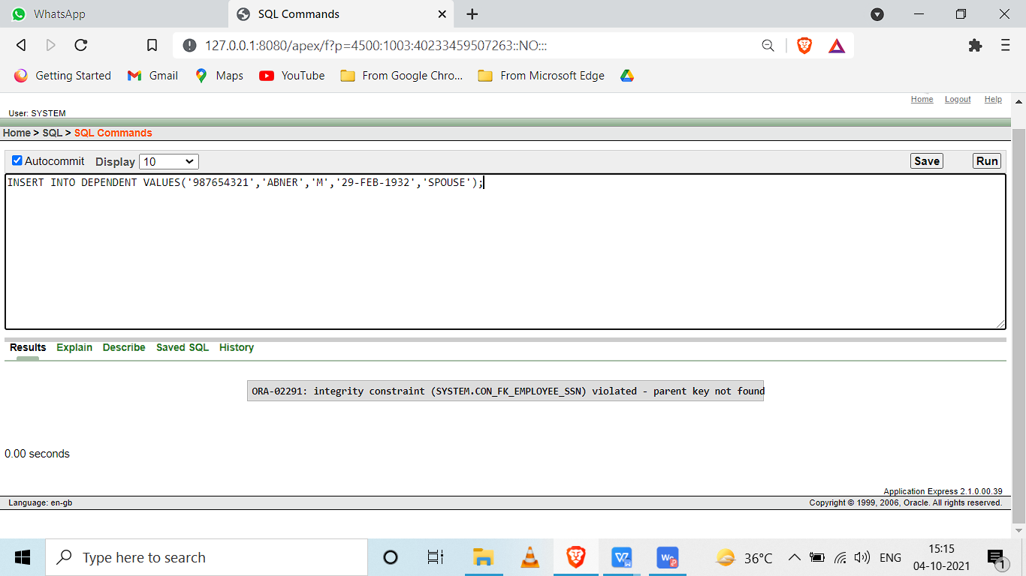

ADDING DUMMY DATA TO EMPLOYEE TABLE

INSERT INTO EMPLOYEE VALUES('CAPTAIN STEVE', NULL, 'ROGERS',987654321,'09-JUN-1902', 'CHENNAI', 'M', 90000, NULL , 4);

INSERT INTO DEPENDENT VALUES('987654321','ABNER','M','29-FEB-1932','SPOUSE');

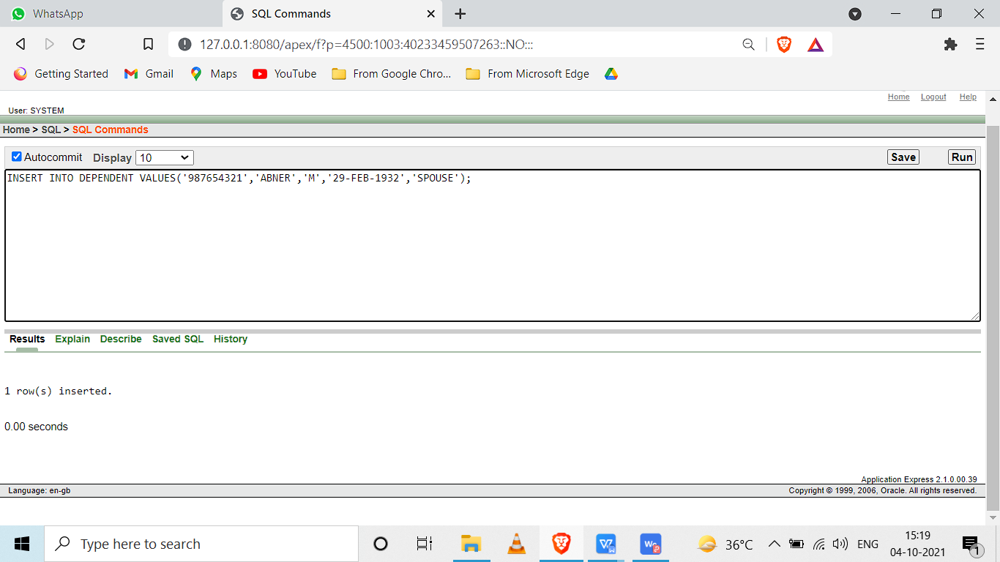

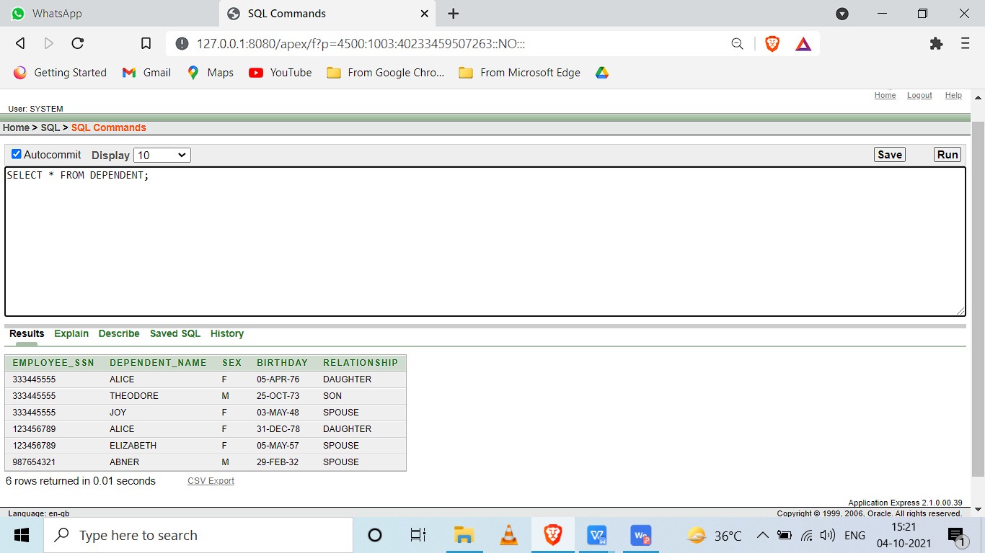

**Execute the following Query on the Db to display and discuss the integrity constraints**

**violated by any of the following operations**

1. Insert ('Robert', 'F', 'Scott', '943775543', '21-JUN-42', '2365 Newcastle Rd, Bellaire,

TX', M, 58000, '888665555', 1 ) into EMPLOYEE.

AS SUPERSSN IS FOREIGN KEY REFERENCING TO SSN

WE DONOT HAVE THE 888665555 IN SSN AS SUPERSSN IS REFERING TO THIS SO WE CANT HAVE 888665555 IN SUPERSSN

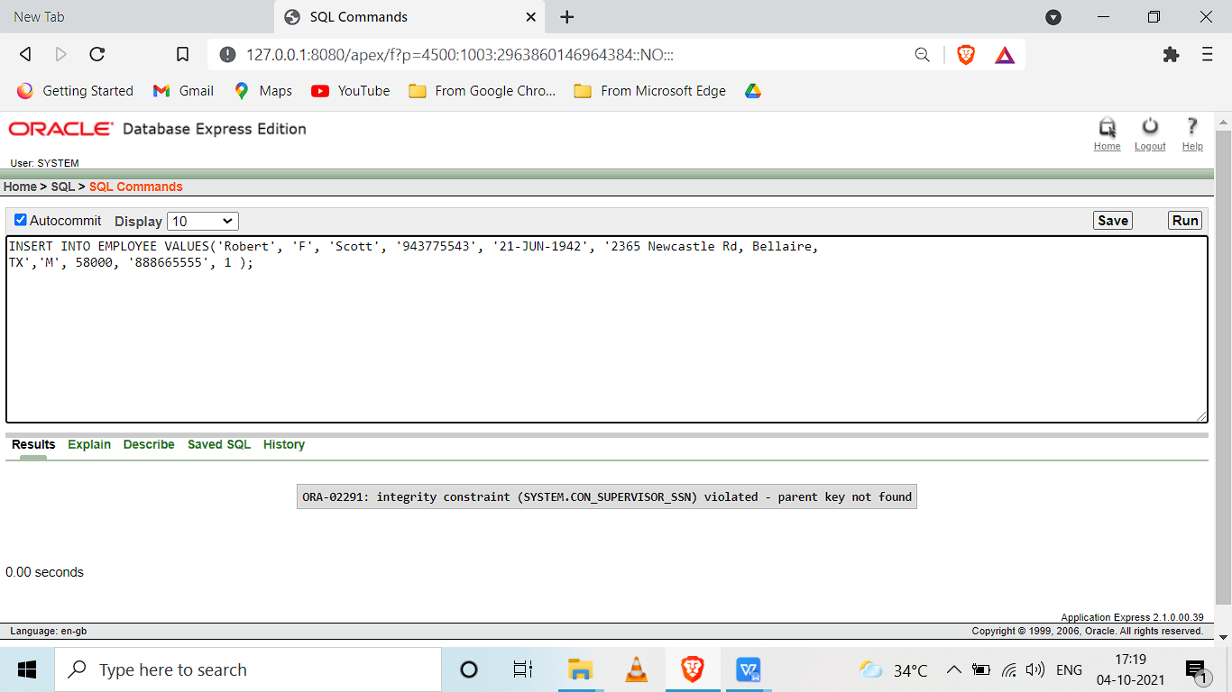

2. Insert ( '677678989', null, '40.0' ) into WORKS_ON.

PROJECT NUMBER IS PRIMARY KEY AND CANT BE NULL.

EMPLOYEE 677678989 IS NOT PRESENT IN EMPLOYEE(SSN).

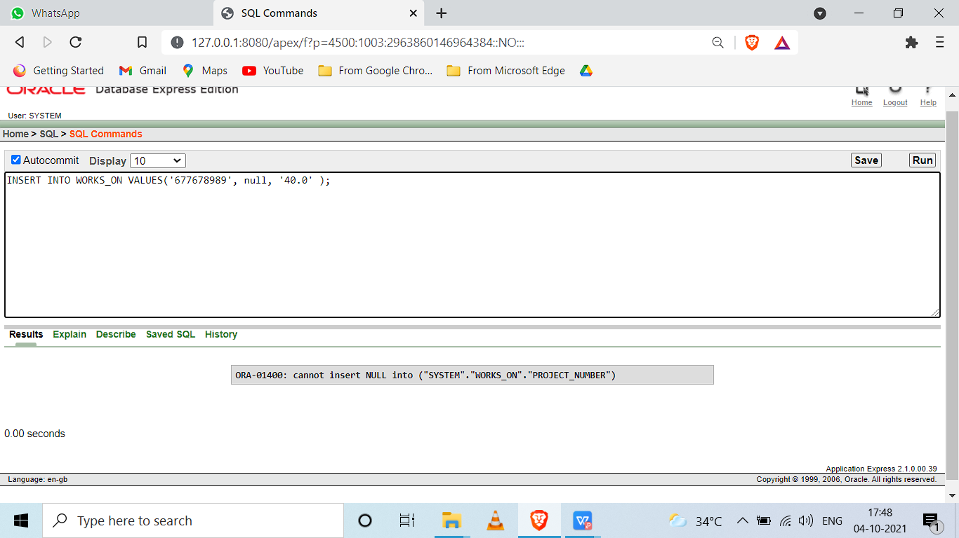

3. Insert ( '453453453', 'John', M, '12-DEC-60', 'SPOUSE' ) into DEPENDENT

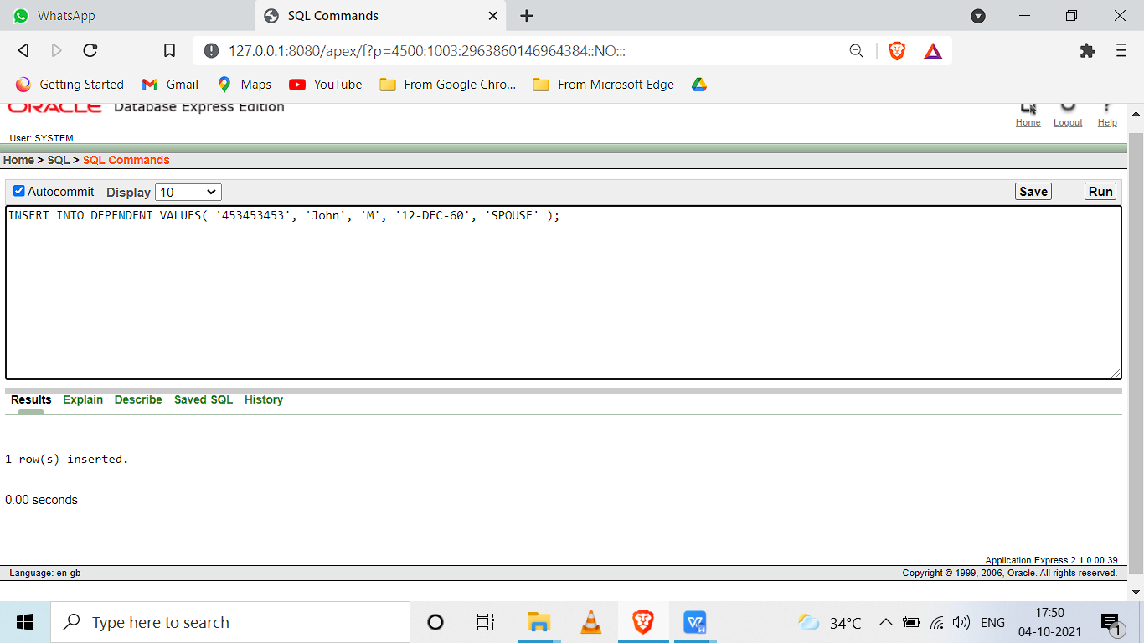

1. Delete the WORKS_ON tuples with ESSN= '333445555'.

DELETE FROM WORKS_ON WHERE EMPLOYEE_SSN = '333445555';

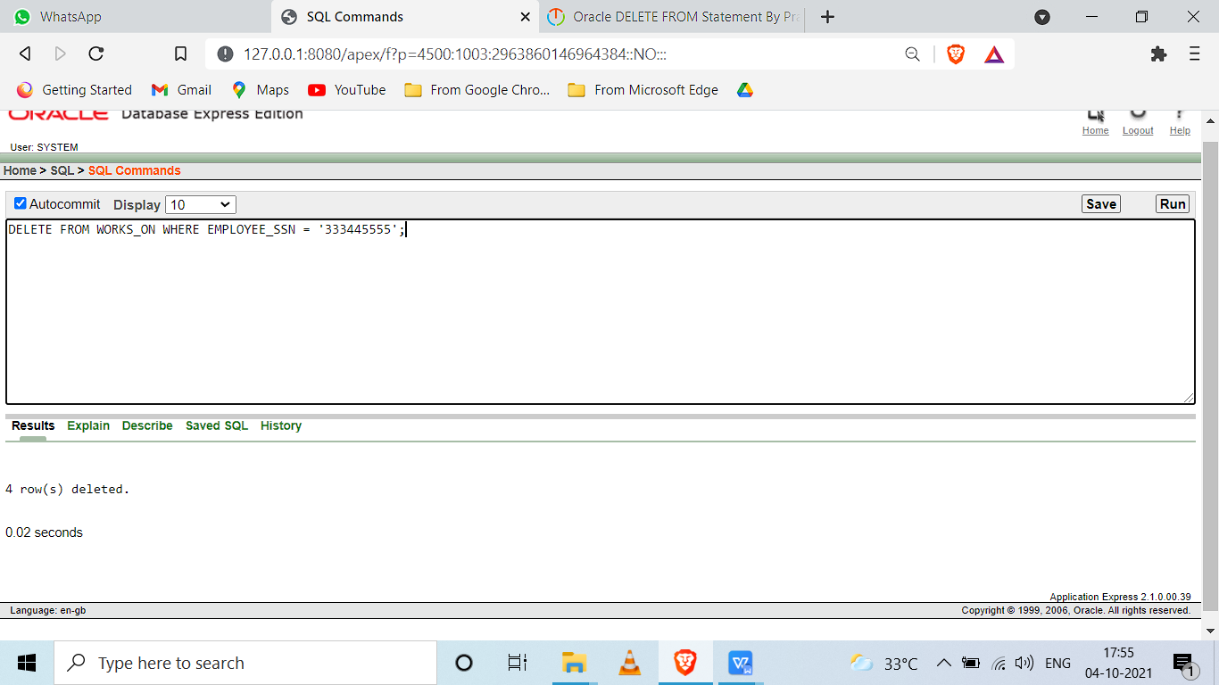

5. Modify the MGRSSN and MGRSTARTDATE of the DEPARTMENT tuple with

DNUMBER=5 to '123456789' and '01-OCT-88', respectively.

UPDATE DEPT SET MANAGERSSN='123456789',MANAGESTARTDATE='01-OCT-1988' WHERE DEPT_NO=5;

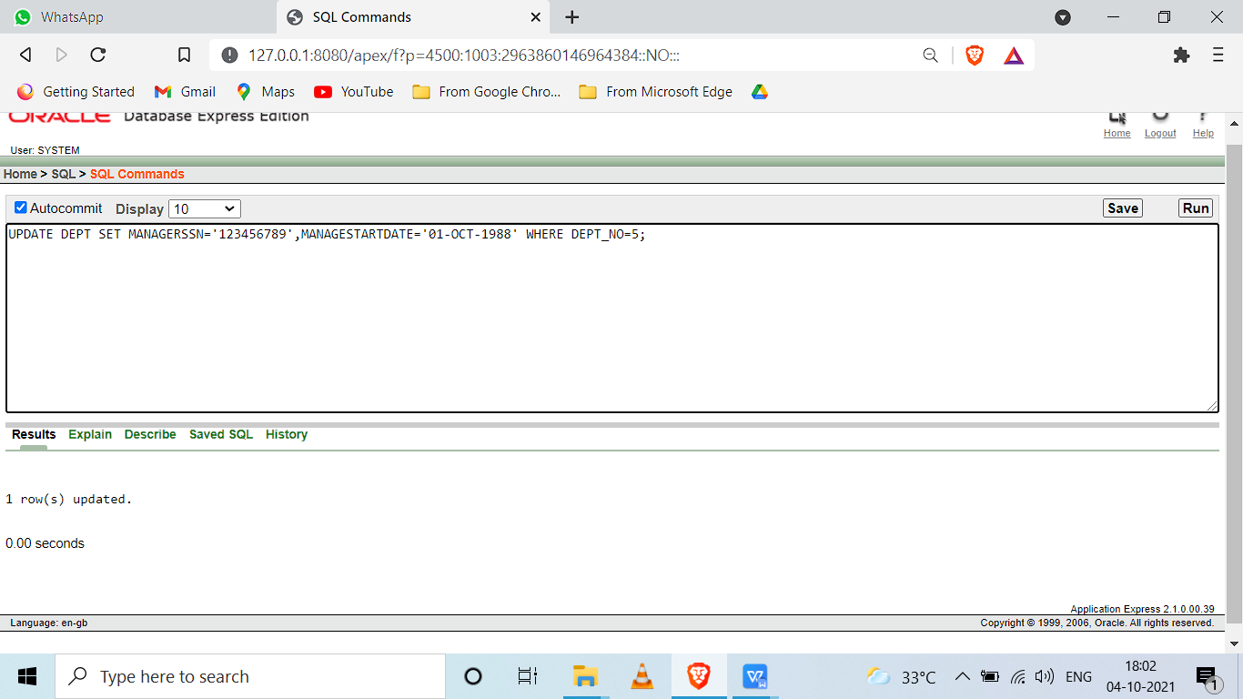

**Alter the tables to**

2. Drop Foreign key defined on SuperSSN and add it using Alter table command.

ALTER TABLE EMPLOYEE

DROP CONSTRAINT CON_SUPERVISOR_SSN;

ALTER TABLE EMPLOYEE

ADD CONSTRAINT CON_SUPERVISOR_SSN

FOREIGN KEY (SUPERVISOR_SSN)

REFERENCES EMPLOYEE(SSN_NUMBER)

ON DELETE SET NULL;

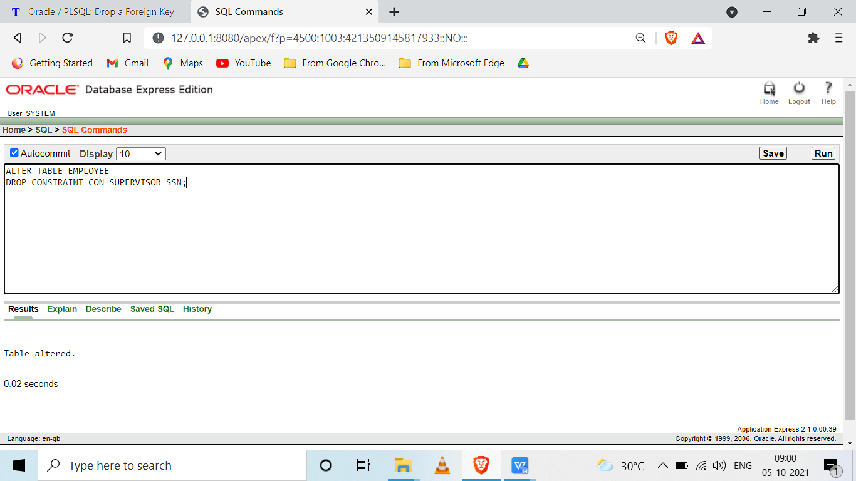

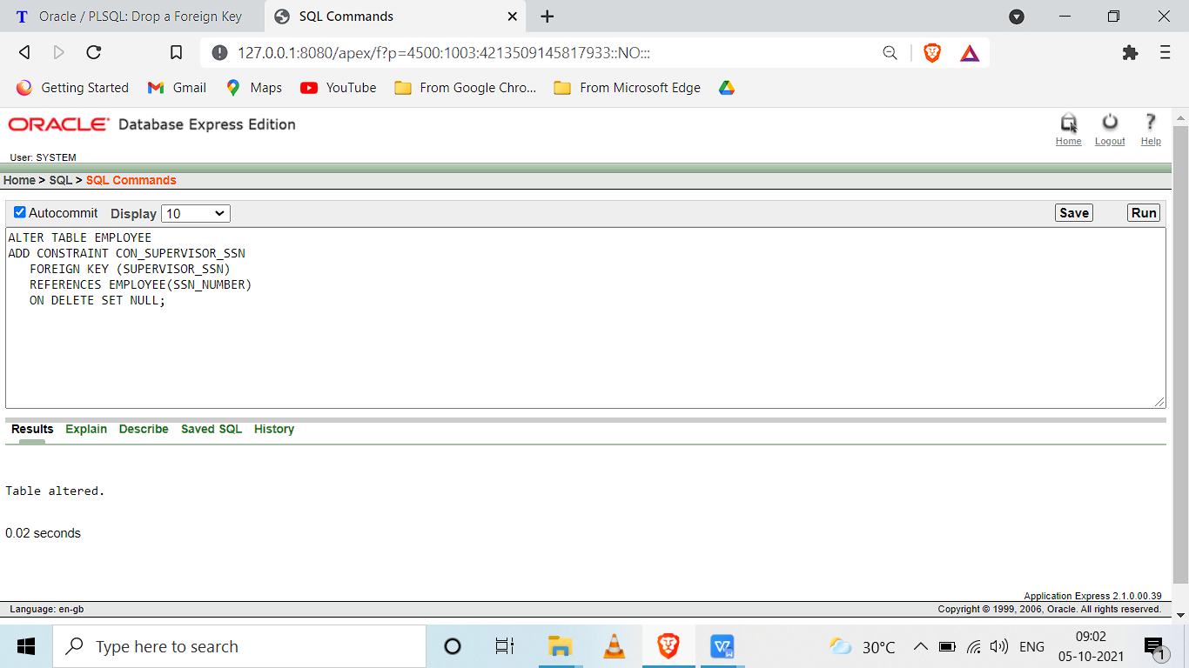

1. Make name of Project as Unique and sex of employee as not null.

ALTER TABLE PROJECT ADD CONSTRAINT CON_UNI UNIQUE (PROJECTNAME);

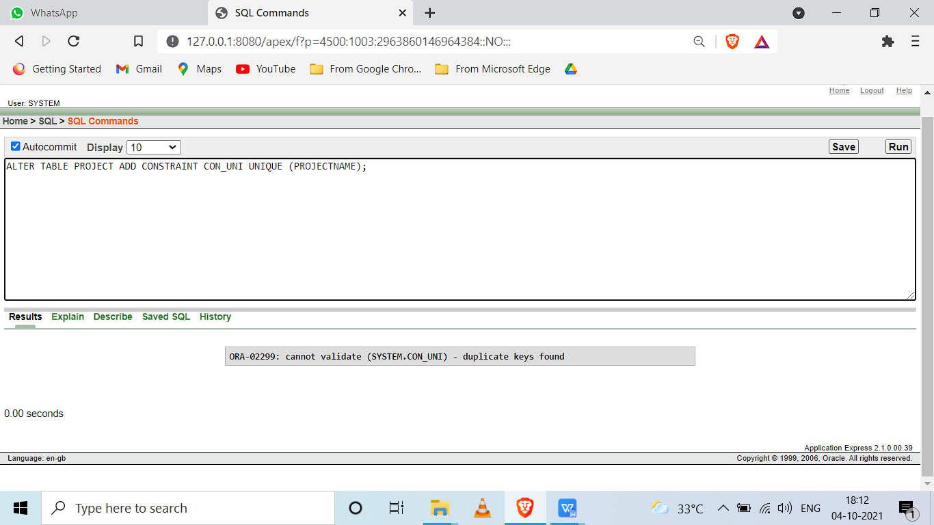

ALTER TABLE EMPLOYEE MODIFY(SEX CHAR(1) CONSTRAINT CON_SEX1 NOT NULL);

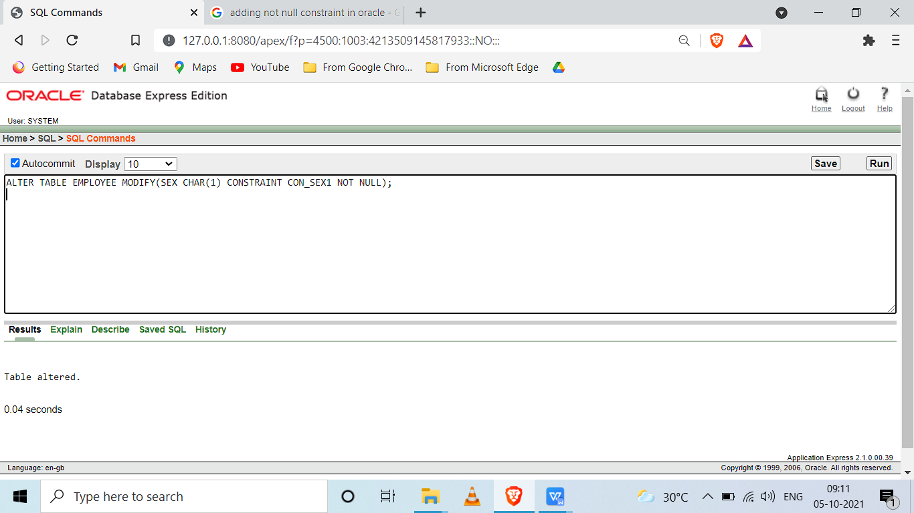

4. Make Address as a new type containing door no, street, city, State, Continent.

ALTER TABLE EMPLOYEE MODIFY ADDRESS VARCHAR(25);

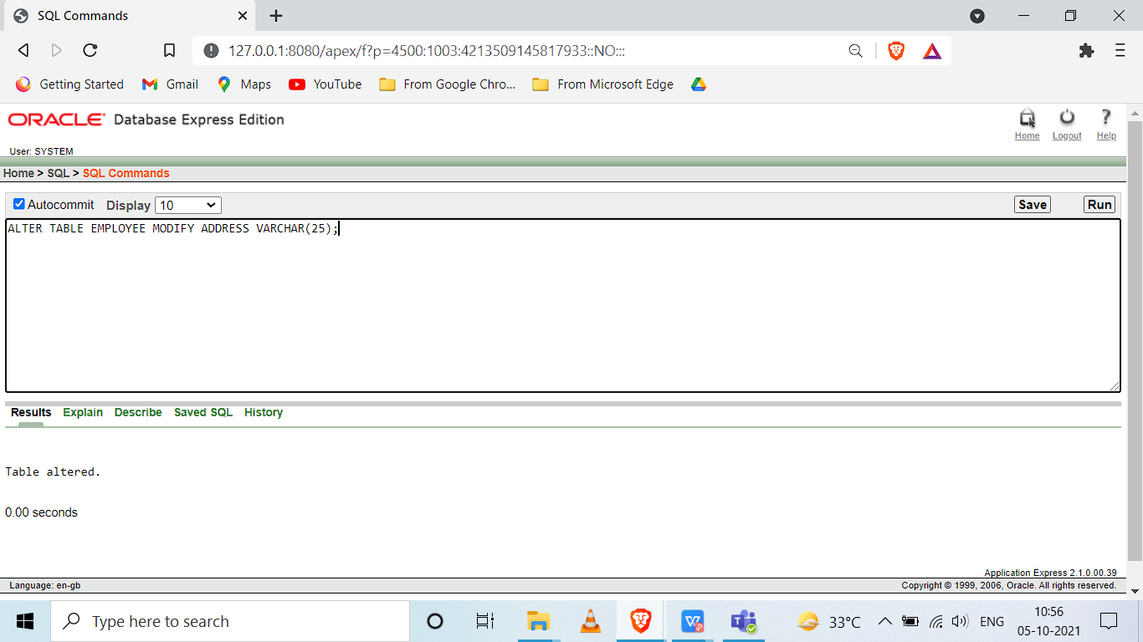

5. Make salary of employee to accept real values.

alter table

EMPLOYEE

modify

(

SALARY NUMBER

);

